Strayer University

**MULTI-TOUCH SCREENS VS. MOUSE-DRIVEN SCREENS**

Week 3

**Assignment**

for the

Course of

**human-computer interaction**

.07/24/17

By

Kennedy Kabaso.

Professor: Edeki Charles.

**MULTI-TOUCH SCREENS VS. MOUSE-DRIVEN SCREENS**

This paper is about the Multi touch screen and mouse driven screen. As you may know Multi touch screen are becoming very popular than mouse driven screens and its industry is growing at an alarming rate. As an Information Technology Director of a major chain restaurant who is responsible for the design of an ordering menu application that can run on all devices. Therefore, I will talk about the advantages and the disadvantages of both, show some example of them in a diagram to make it easy to understand, differentiate between the interaction types and styles that apply to multi-touch screens and applications running on them. Then talk about the model that I will use when designing a product for the restaurant, describe the key analogies and concepts monitors expose to users and Lastly, talk about tool in an application for touch-based and mouse-drive screens that should be designed with memory recall.

Before I go any further, I would like to define these terms to make an understanding easy. What are Multi touch and mouse driven? According to Wikipedia and I quote “ multi-touch is technology which enables a [trackpad](https://en.wikipedia.org/wiki/Trackpad) or [touchscreen](https://en.wikipedia.org/wiki/Touchscreen) to recognize more than one or more than two [points of contact](https://en.wikipedia.org/wiki/Somatosensory_system) with the surface” Mouse driven on the other hand, is the use of a mouse which can be achieve by physical using your hand to controls the cursor and the digital interface on the screen which can be touch with the cursor. Both of them have some advantages and disadvantages. Multi touch are fast and easy to use while mouse driven are slow and can be a challenge for non tech people. A touchscreen is very intuitive easy to use (as the user simply touches what he or she sees on the display). In addition, it saves space as no keyboard or mouse is required and Touch monitors can be mounted on the wall.

**Differentiate between the interaction types and styles that apply to multi-touch screens and applications running on them**

In differentiating the interaction types and styles on both screen, I will start with the two screen which work different. The Multi-touch screen and Mouse-Driven Screen are going to have different interface. The Multi - touch screen will have an interface which let a user to interface with it by touching the screen using anything like a hand or finger. This will in turn cause an application to start running and do what is ordered. The Mouse-Driven Screen on the other hand is going to have a screen which can be interface using a mouse by user in making an order.

This can be done by let the mouse cursor to be always on the screen which unable the computer knows its presence. The mouse can trigger changes on screen without a click which put it on an advantage compared to the touch screen. When it is over a button or a menu, the interface can change color or reveal options without having to actively ask for them. With the touch screen, the user sees an item they want, locates a finger or some part of their hand to the item and then touches the item while on a mouse driven screen, they can see an item they want, locates the mouse to that item and then clicks.

**Determine the conceptual model that you would use when designing a product for your restaurant.**

On determine the concept model for our restaurant, we want to build the restaurant which can save people to buy different types of food which is going to be saved fast and meet the customer expectation. These three important things which we are going to focus on are very important now and in the future. Our great menu we will provide is unbeatable by most of the restaurant in the country. In order to deliver the service at the needed time, we are going to recruit the best people to do the job well and have competitive pay in the food business. Our style of service is going to be simplified by these electronic monitors devices which will make the ordering easy. And we are committed to meet our customer needs by making sure that the order is done in a timely manner. This is going to be achieved by providing two types of menu on the electronic devices. This can be achieved by providing two types of ordering service menu which are Multi touch screen and mouse driven screen. The user can choice which work for them and we will do our best to serve them better. Moreover, these screen will play an important role in our ordering system. As everybody knows that time is very important in our country, customer can order the meal on the phone while driving using the touch screen or at the office. By the time they come and pick up their order, they will find it ready. All they have to do is just enter the order number on the monitor and drive to the next window to pick it up.

**Describe the key analogies and concepts these monitors expose to users, including the task-domain objects users manipulate on the screen**.

On the issue of key analogies and the concepts the monitors expose to users, the Mouse-driven monitors and touch screen monitors based ‘s main analogies are the selecting capabilities which they all have that makes it possible to order food from the menu. I can explain its analogies in many different ways such as hard to see, the speed of each screen, the selecting technique of each, and small and accuracy

On the point of hard to see can be explained on the cursor which is small. It was made small so that it cannot cover the things which can be selected. In addition, it can be lost if not careful followed. That fine-tuned selection ability comes with a weakness, and that is the cursor is small. This is also to prevent it from covering everything as you use it. Anyone who has used detailed tools in Photoshop can tell about that. And when you’re using two or three screens the cursor is easy to lose.

If it come to how fast a user can order food, the touch screen does a better job. It is very easy for a user to order food fast by just touch which can be done quickly with a finger, hand or a pen. The mouse on the other hand takes long time to use.

In order to select the items correctly, a mouse curser does a good job because it is small. The smaller it can be; the more accuracy it can select. It can select a single pixel buttons easily and if you want to do something that requires fine control or lots of detail, a mouse will perform better.

Select easily cannot be done by the touch based screen because it is difficult to do it with a finger, a hand or a pen tip. A mouse on the other hand can click small areas, between individual letters to select a specific area which put it on a big advantage over fingers. Touch based block the view and scroll the screen when a user touch and drag. This result in a mouse cursor a much better when it comes to working with text and image editing, which require careful content selections, or games that require precision.

**Determine one (1) utility / tool in an application for touch-based and mouse-drive screens that should be designed with memory retention recall. Provide a rationale**

One of the tools I will use is the graphical user interface (GUI).It is a type of [user interface](https://en.wikipedia.org/wiki/User_interface) that allows [users](https://en.wikipedia.org/wiki/User_%28computing%29) to interact with computer through graphical [icons](https://en.wikipedia.org/wiki/Computer_icon). It requires few skills which makes it useable by anyone who do not have technology skills. Therefore, it is going to be good for both the touch-based and mouse-drive screens. Users can find it easy to use and figure out which is going to provide fast services. In addition, this tool brings high Productivity to the restraint. I have include a user case diagram of someone ordering food which is going to make some sense to understand below.

**A use case diagram for the Customer ordering food.**

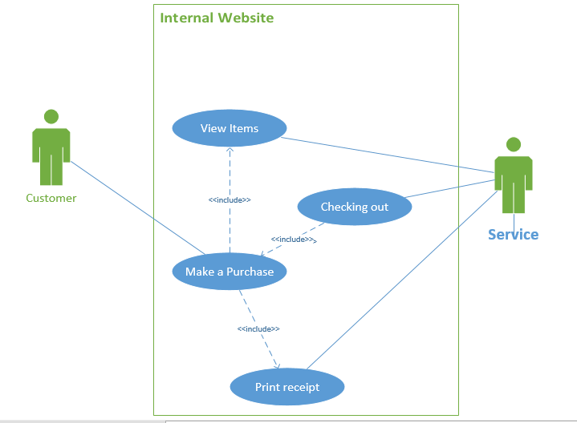

**Conclusion**

Finally, the touch screen devices will be the next booming industry because it is simple to be used by everybody regardless of age because almost everybody can find touching easy than trying and mouse using. In addition, touch screen is the next generation industry because more and more can multitask with the touch screen which is easier than searching for keys on the key board and it is power by an advancement in user interfaces. Moreover, touch screen will be the next generation booming industry due to increase in smartphones and the increase in flat screen TVs

6.) Draw a fowchart or write pseudocode to represent the logic oF a program that allows the user to enter two values. The program outputs the product oF the two values

The lab requests you to read to variables, multiply the variables together, and print the answer. Unfortunately you sent a discussion.

The input commands worked well. The output worked well without any problem at last. The only thing which was a little bit of a problem was when I left the double quotation marks. The program did not work until I realized I left the them. Then I put them and everything worked well. Otherwise, the Lab was good and everything is working properly.

Lab 3: Exercise 5 (Part A) on page 172 (20 points)

5. Assume that you have created a mechanical robot that can perform the following tasks:

  Stand up.

  Sit down.

  Turn left 90 degrees.

  Turn right 90 degrees.

  Take a step.

Additionally, the robot can determine the answer to one test condition:

  Am I touching something?

a. Place two chairs 20 feet apart, directly facing each other. Draw a structured flowchart or write pseudocode describing the logic that would allow the robot to start from a sitting position in one chair, cross the room, and end up sitting in the other chair. Have a fellow student act as the robot and carry out your instructions.

b. Draw a structured flowchart or write pseudocode describing the logic that would allow the robot to start from a sitting position in one chair, stand up and circle the chair, cross the room, circle the other chair, return to the first chair, and sit. Have a fellow student act as the robot and carry out your instructions.

(Farrell)

Farrell, Joyce. *Programming Logic and Design, Comprehensive, 8th Edition*. Cengage Learning, 20140128. VitalBook file.

The citation provided is a guideline. Please check each citation for accuracy before use.

**Bibliography**

1. Dearden, A. (2008). [User-Centered Design Considered Harmful](https://smartech.gatech.edu/bitstream/handle/1853/48573/User%20Centered%20Design%20Considered%20Harmful.pdf?sequence=1)
2. Norman, D. (2007–2010). [Activity-centered design: Why I like my Harmony remote control](http://www.jnd.org/dn.mss/activitycentere.html)
3. <http://thehipperelement.com/post/47937273876/touch-vs-mouse>
4. http://pathfindersoftware.com/2010/10/designing-touch-science-tap-click/
5. <https://www.webstaurantstore.com/article/149/how-to-choose-a-restaurant-concept.html>
6. [www.wikipedia.com](http://www.wikipedia.com)